

***Gambar*** *3.2 Use Case Diagram Sistem Perkuliahan STMIK Muhammadiyah Jakarta*

### Use Case Diagram Sistem Perkuliahan



***Gambar*** *3.3 Activity Diagram Sistem Perkuliahan STMIK Muhammadiyah Jakarta*

### Use Case Diagram Sistem Perkuliahan

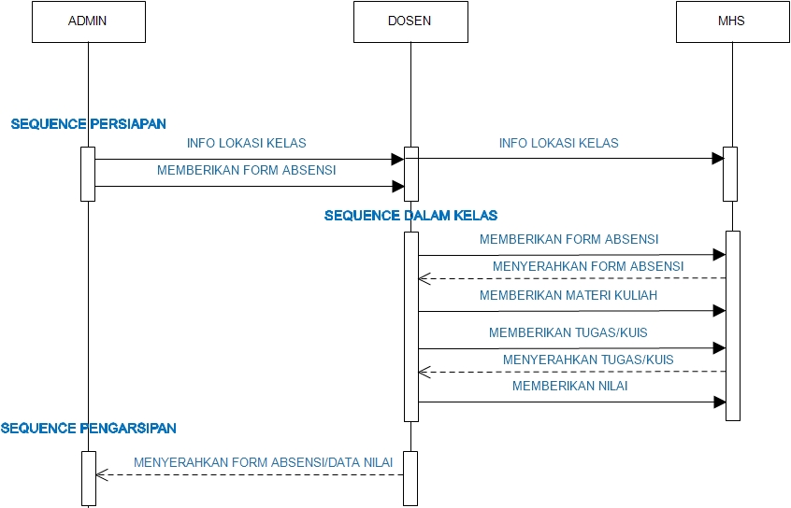

***Gambar*** *3.4 Sequence Diagram Sistem Perkuliahan STMIK Muhammadiyah Jakarta*